Step3: In the SVN Repositories view, select “New repository”. The Create SVN Repository dialog appears.

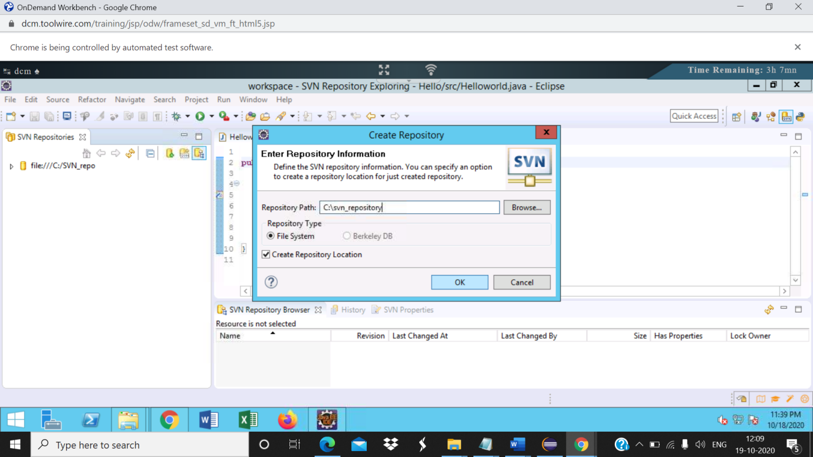

Step4: In the “Create SVN repository “dialog box , click on browse -> select the repository you created and click ok.

New repo is created

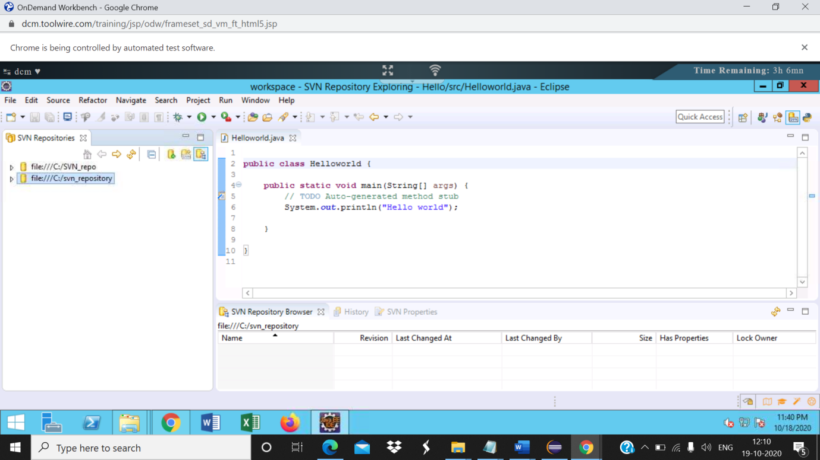

Step5: Open the explorer and navigate to the created repository. It should contain the following folders and files created automatically:  
a. conf  
b. db  
c. hooks  
d. locks  
e. format  
f. README

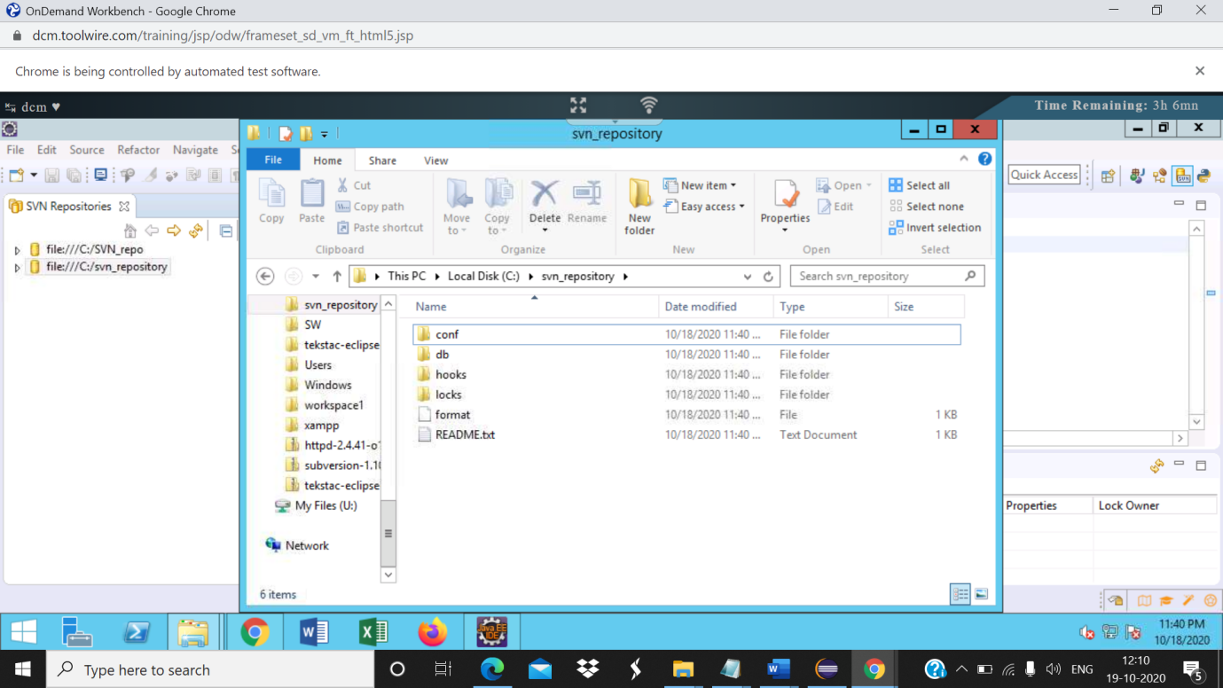

Step6: In eclipse, right click on the newly created repository and select “New”->”New folder”

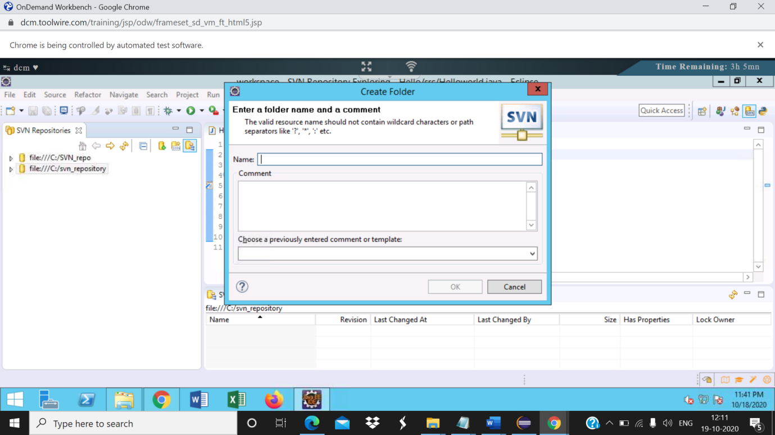

Step7: In the New remote folder dialog, enter the folder name as trunk and click on Next.  
Enter the commit message in the next screen and click on finish

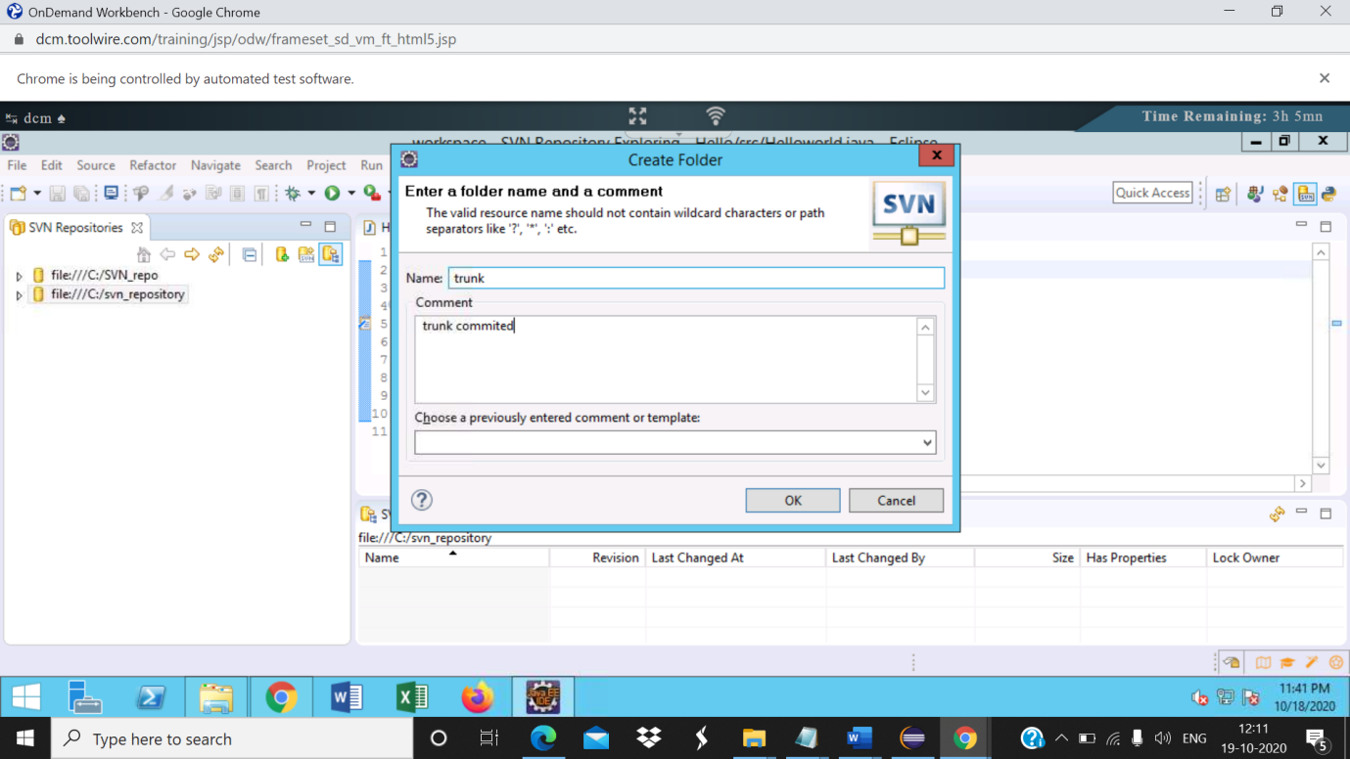

Trunk is present

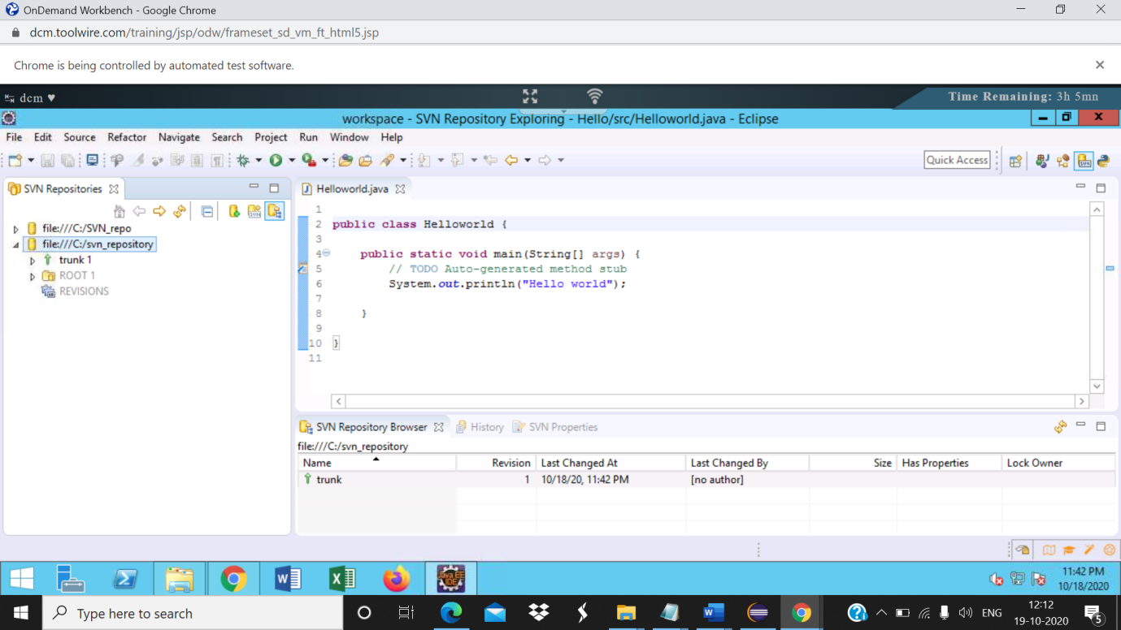

Step8: Create the tag and branch directories similarly

Tag created-

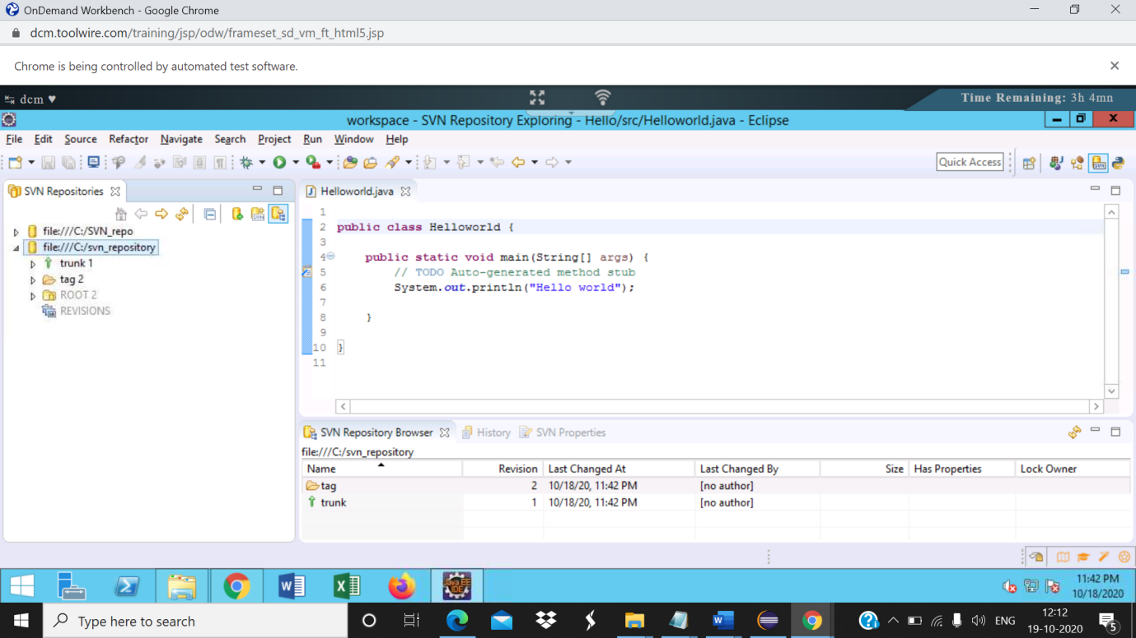

Branch created

Step10: In the import directory, browse and select**C:\svn_projects\project7**, enter the comments and click ok.Refresh the trunk.The project is added to the trunk

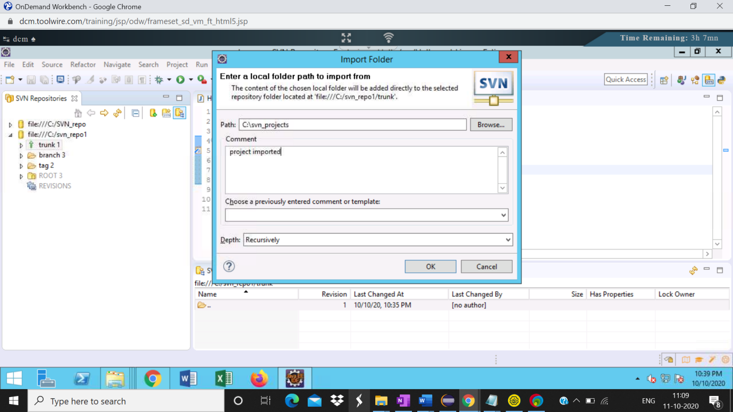

Project imported

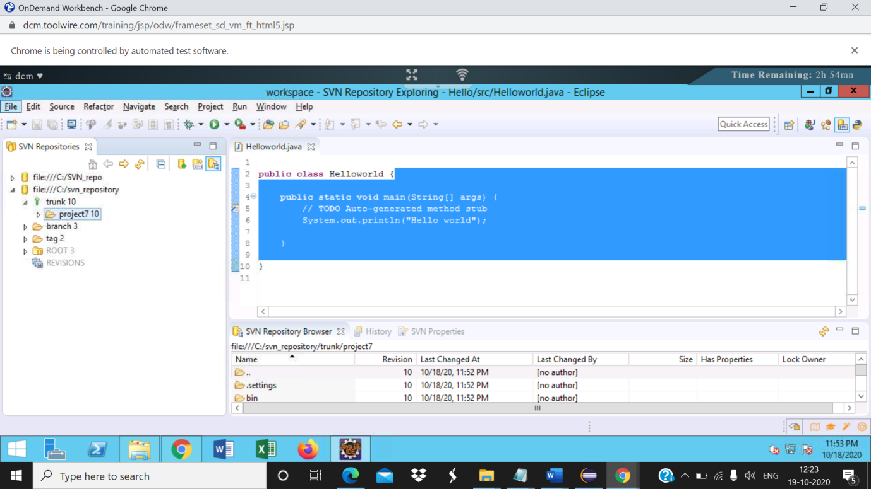

Step11 :Now checkout the project into the workspace.  
Right click on project and select checkout

Project explorer screenshot

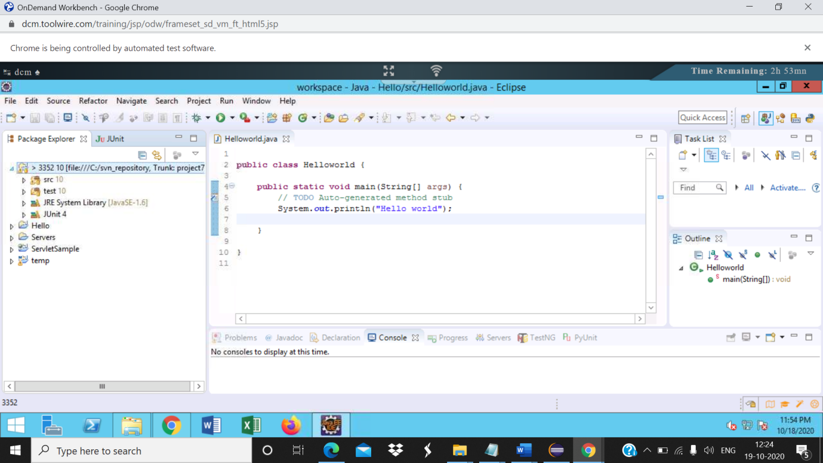

|  |  |  |
| --- | --- | --- |
| 13 | Right click on the project and select Team->commit |  |

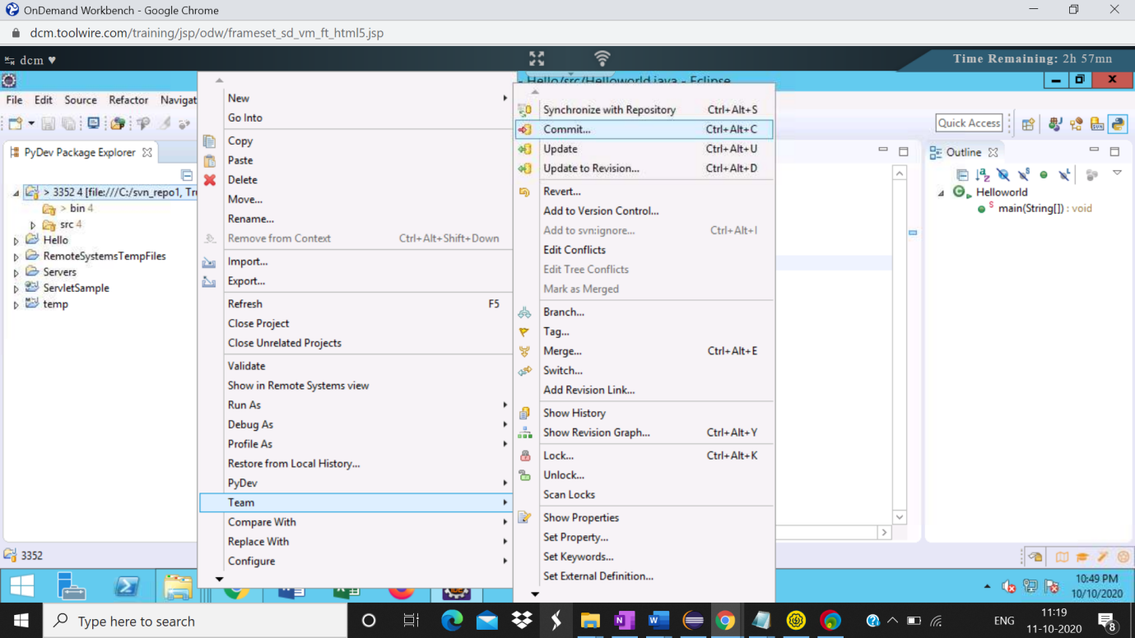

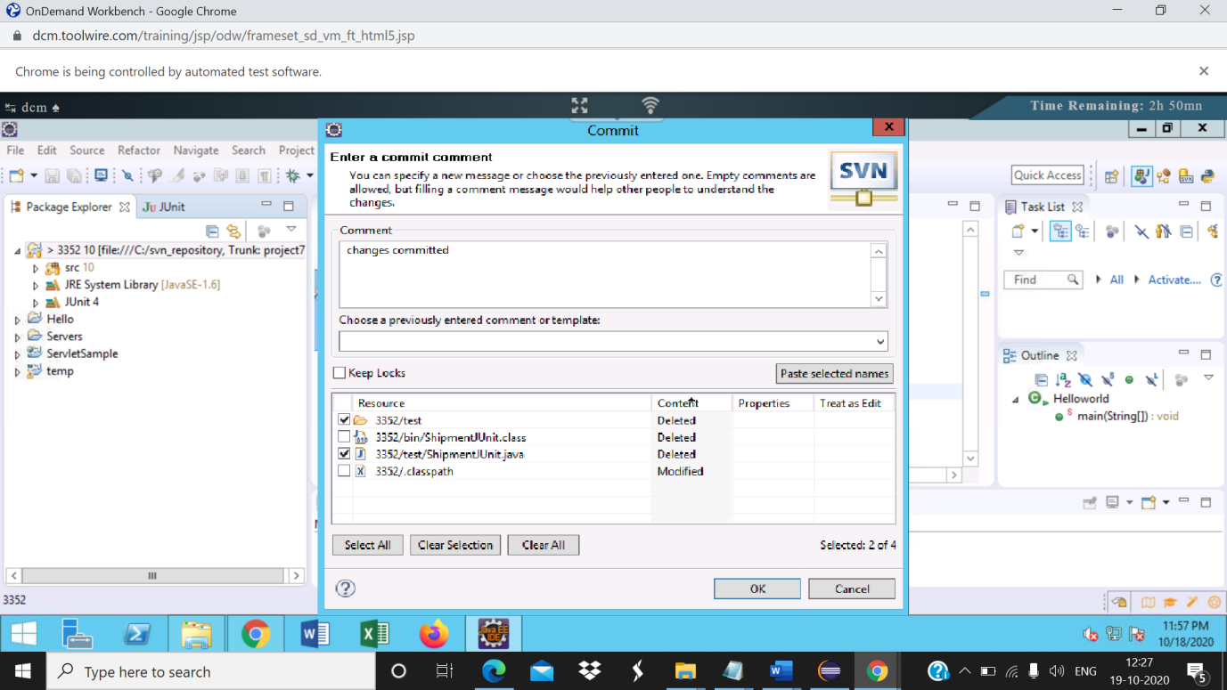

Step14: Verify the files, enter the commit message and click ok

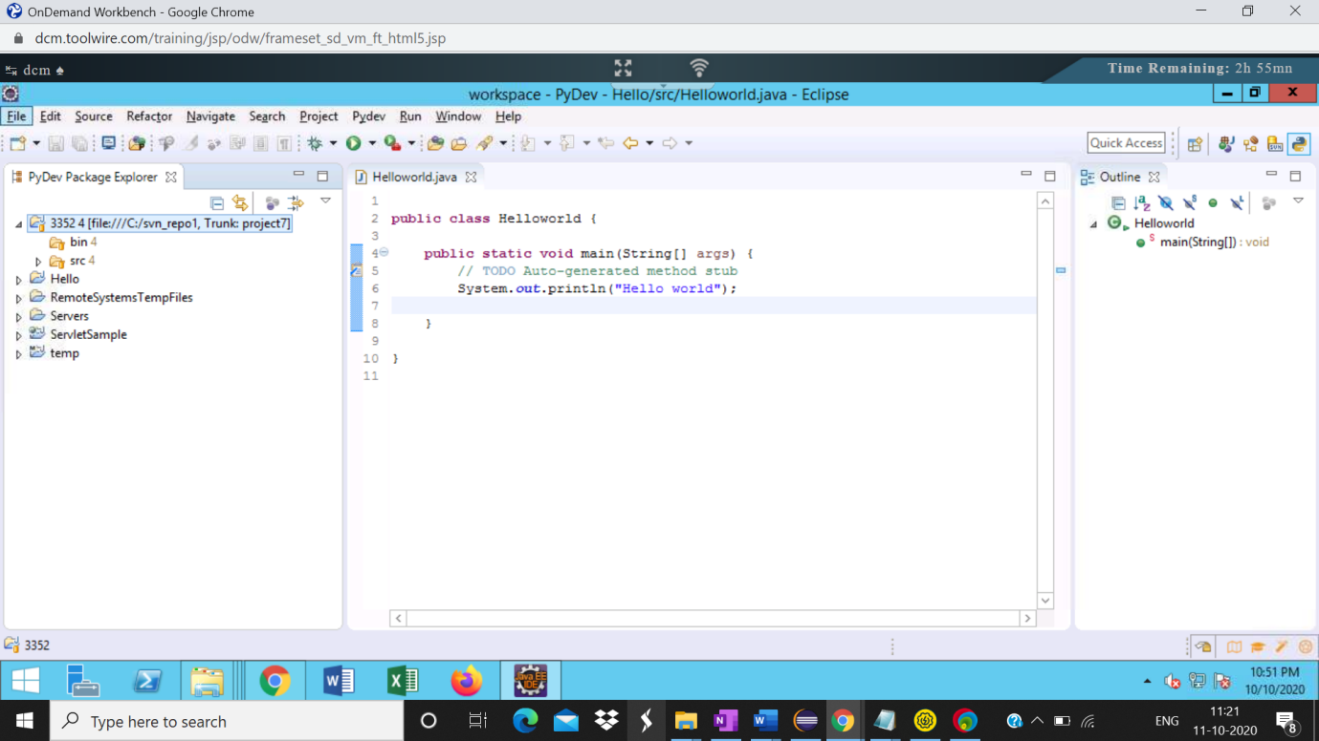

15 Right click on the repository and select show history

